Registers 2, 3 — Temperature Limit Registers (address = 02h, 03h) (Read/Write)

Description:

The THIGH and TLOW registers are used to store the temperature limit thresholds for the TMP104 watchdog function. At the end of each temperature measurement, the TMP104 compares the temperature results to each of these limits. If the temperature result is greater than the THIGH limit, then the FH bit in the configuration register is set to '1'. If the temperature result is less than the TLOW limit, then the FL bit in the configuration register is set to '1'; see Figure 11.

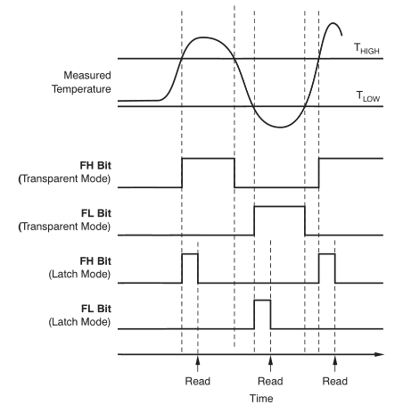
Figure 11. Temperature Flag Functional Diagram

Table 8 and Table 9 describe the format for the THIGH and TLOW registers. Power-up reset values for THIGH and TLOW are: THIGH= +60°C and TLOW= –10°C. The format of the data for THIGH and TLOW is the same as for the Temperature Register.

Table 8. THIGH Register
BIT # | D7 | D6 | D5 | D4 | D3 | D2 | D1 | D0
BIT Name | H7 | H6 | H5 | H4 | H3 | H2 | H1 | H0

Table 9. TLOW Register
BIT # | D7 | D6 | D5 | D4 | D3 | D2 | D1 | D0
BIT Name | L7 | L6 | L5 | L4 | L3 | L2 | L1 | L0

